Task1: 3D CAD Model Creation

- Project Title: Connecting Rod Design
- Software Used: SolidWorks 2020
- Material: Polished Aluminum

Project Description:
A 3D CAD model of a connecting rod was designed using SolidWorks. The model includes the main geometric features of a connecting rod with proper dimensions and material assignment. The design was created as a solid part and visualized through different views

Included View

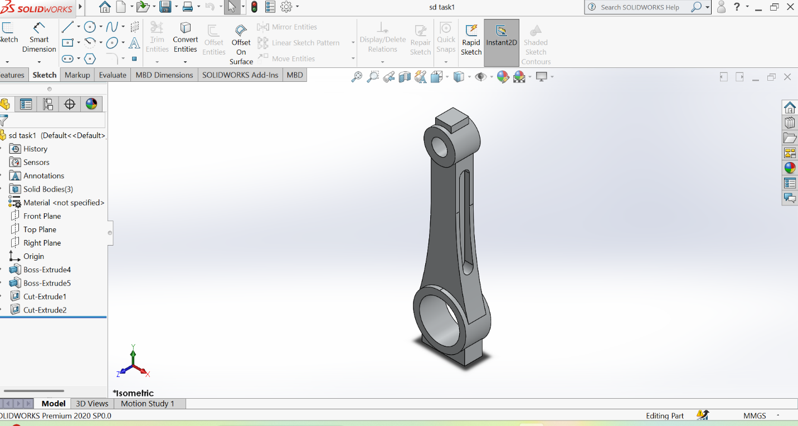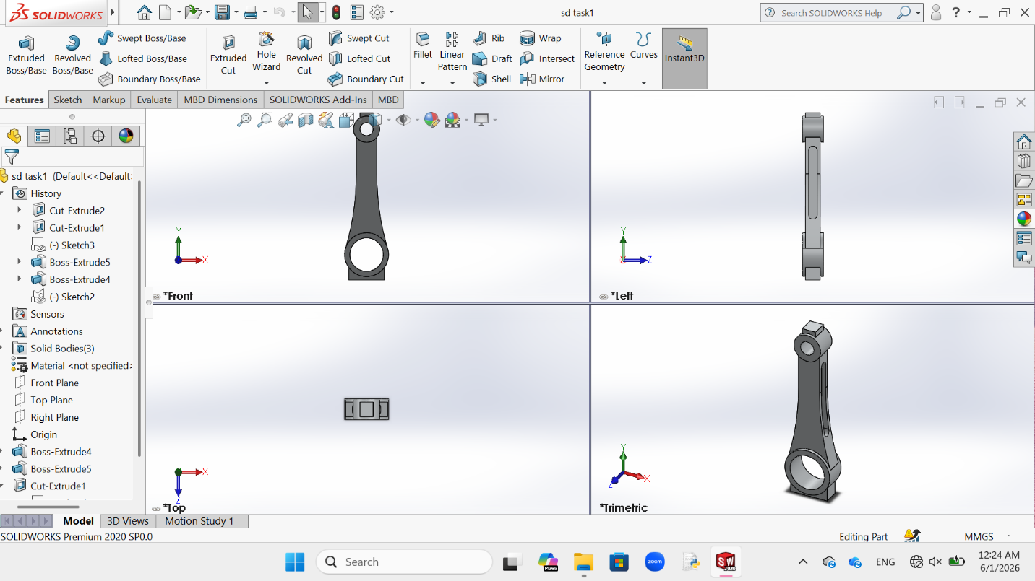

Main Dimensions

- Big End Outer Diameter: 42 mm
- Big End Inner Diameter: 32 mm
- Small End Outer Diameter: 25 mm
- Small End Inner Diameter: 12.5 mm
- Center Distance: 120 mm

